1. Patterns and colors are essential to maps. Compare a search for Harvard University on two interactive maps ( e.g. Google Maps, Bing Maps, Yahoo Maps, Apple Maps, map.harvard.edu). Answer the following questions, making references to concepts explained in Ware such as pattern recognition and properties of color. Please include screen shots of the examples you are comparing.

* Which map promotes an easier visual search for buildings?

In my opinion Bing maps provided with a better visual experience to search for buildings on campus since the building labels were available. The navigation was a bit slow and the zoom in during the search process is slow but is a smooth experience. The “eye bird” view actually depicted in good perspective the location of the building in relation to the space.

In the case of google maps, I felt that navigation was faster bit the zoom in was very fast a abrupt which brought me abruptly in the satellite view. Yet in satellite view, the label for the building was not present.

* Which map more effectively visualizers routes from a random point A to point B?
* Which map is an overall better visualization, and why?

To answer this question, I have chosen Google Maps and Bing Maps. The following are the first screen shows I viewed upon launching both interactive Web applications:

Google Maps :

a) Simple search for “Harvard University”:

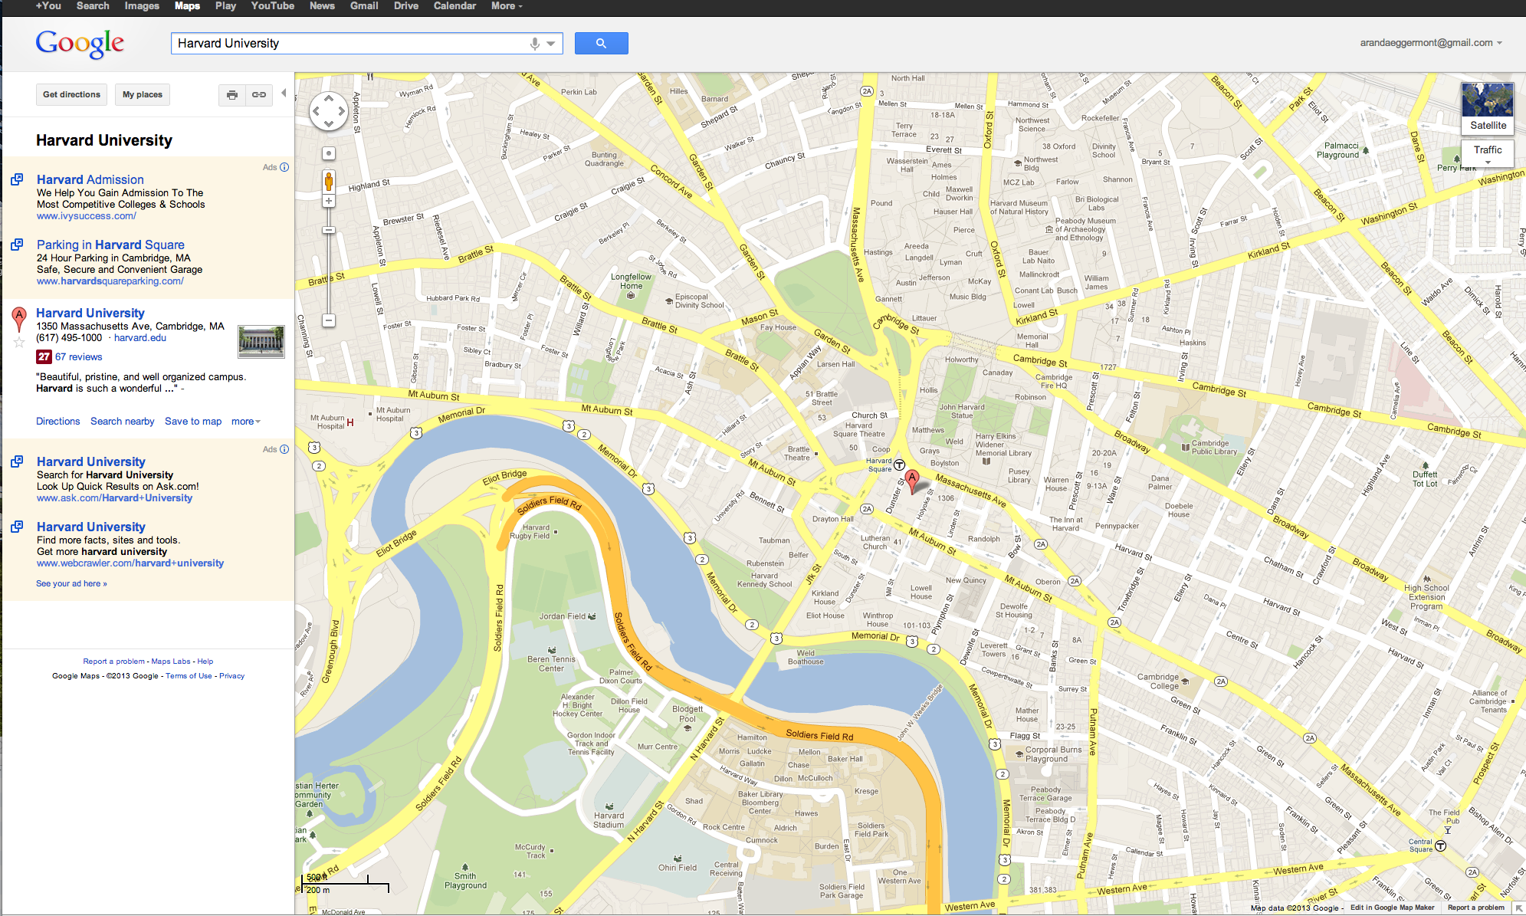

b) Search for “Server Hall” building:

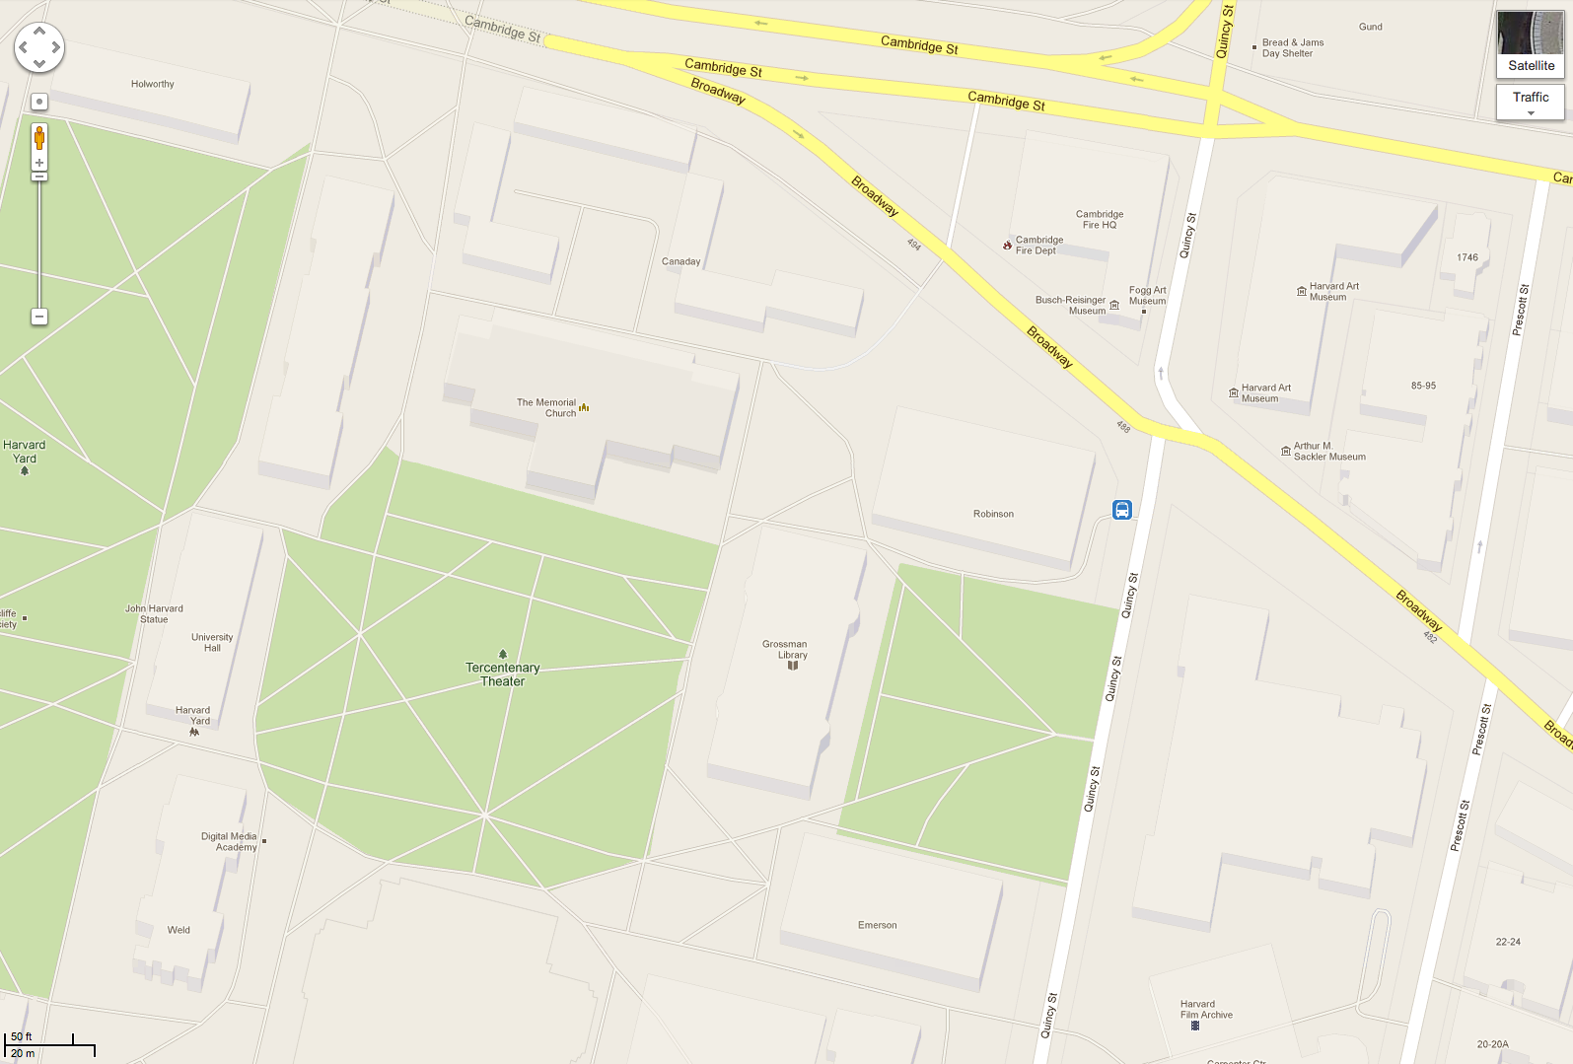

Satellite view:

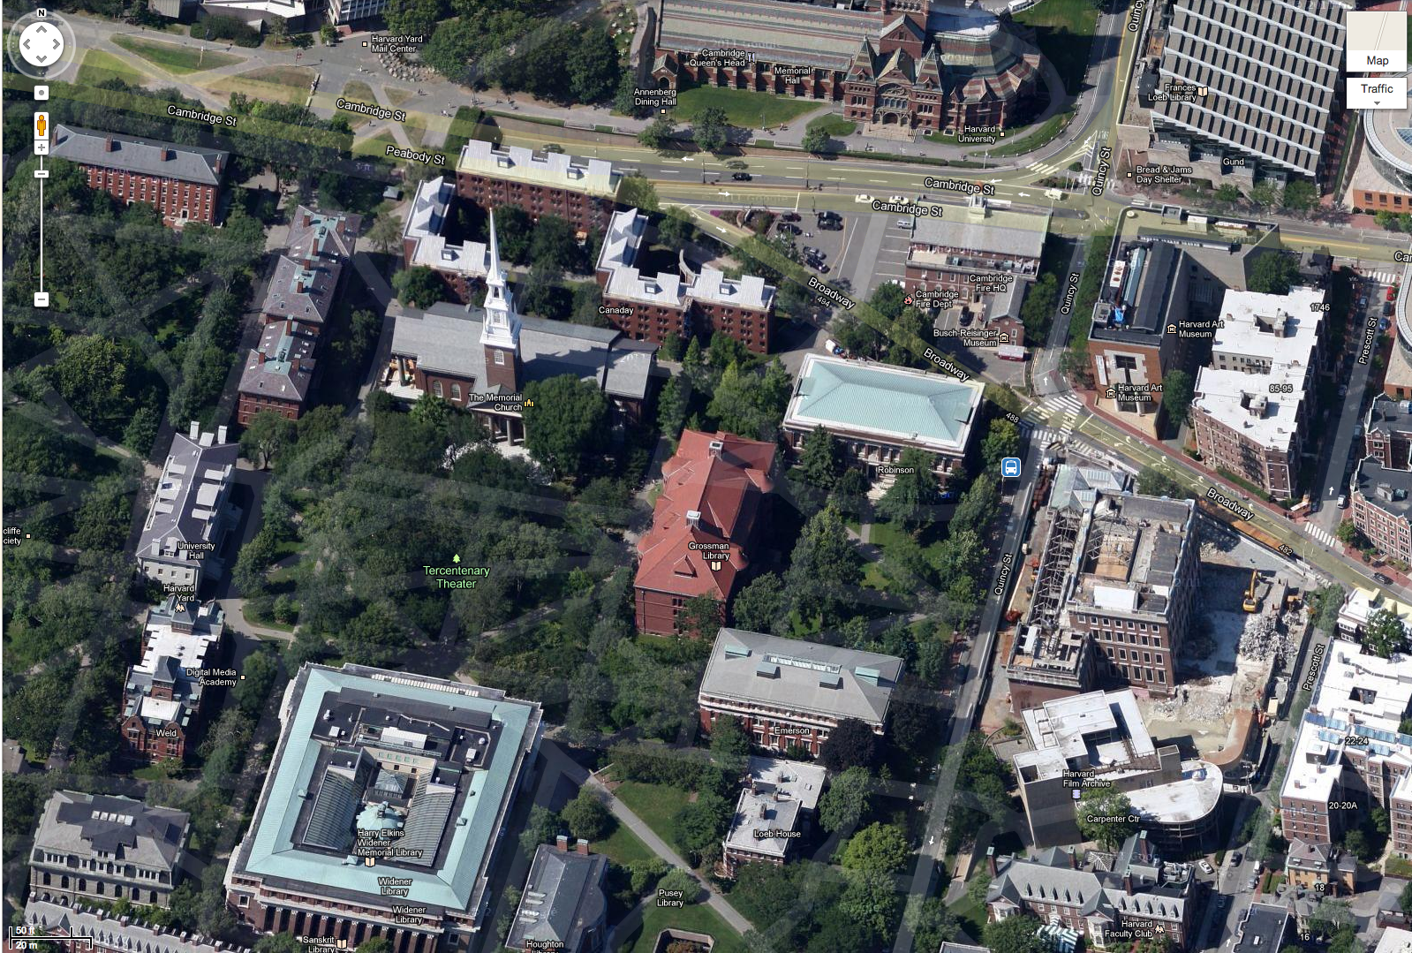

Path search:

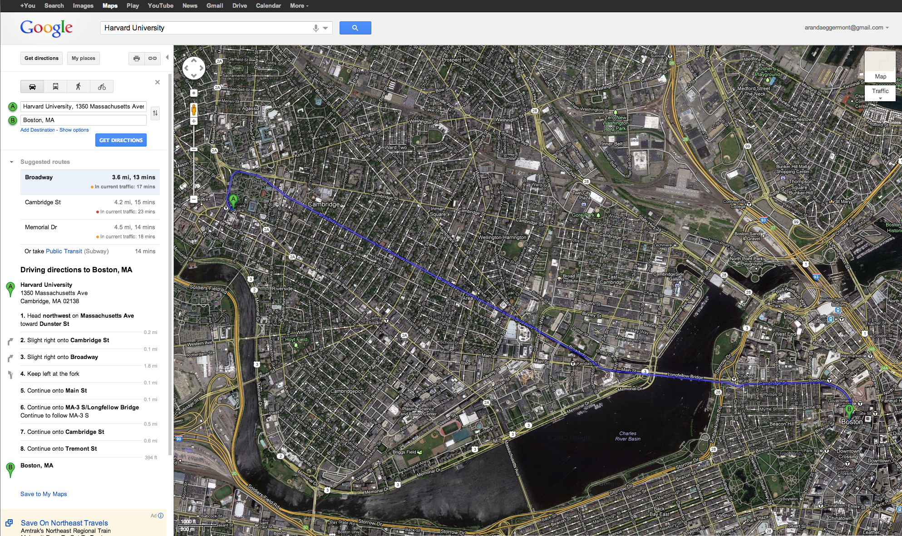

Bing Maps:

a) Simple search for “Harvard University”:

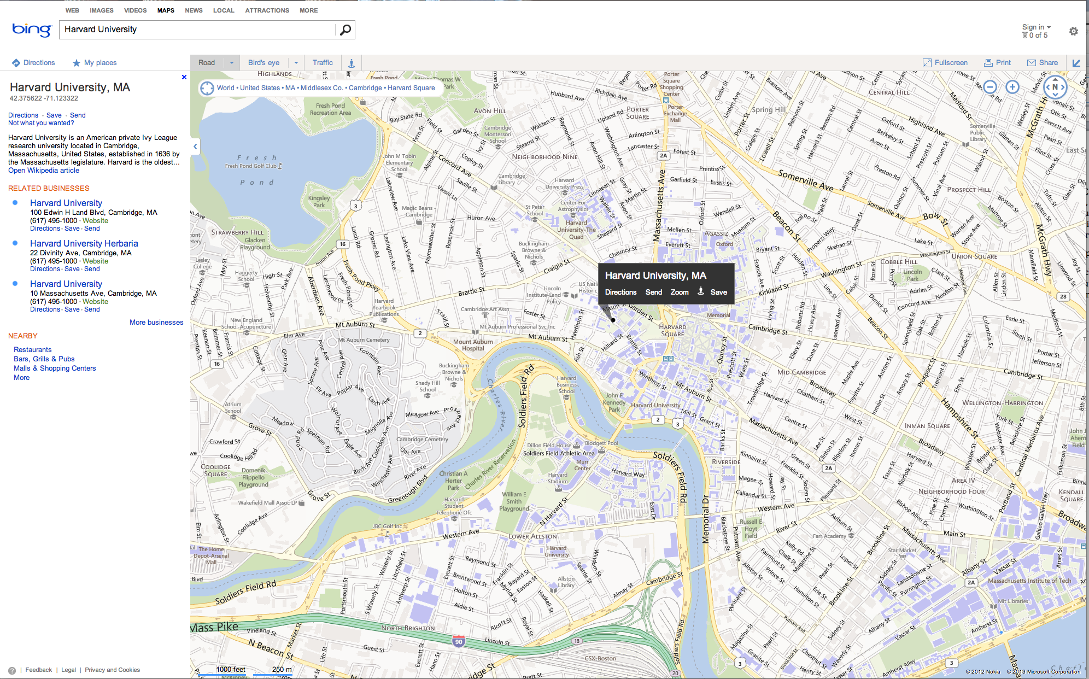

b) Search for “Server Hall” building:

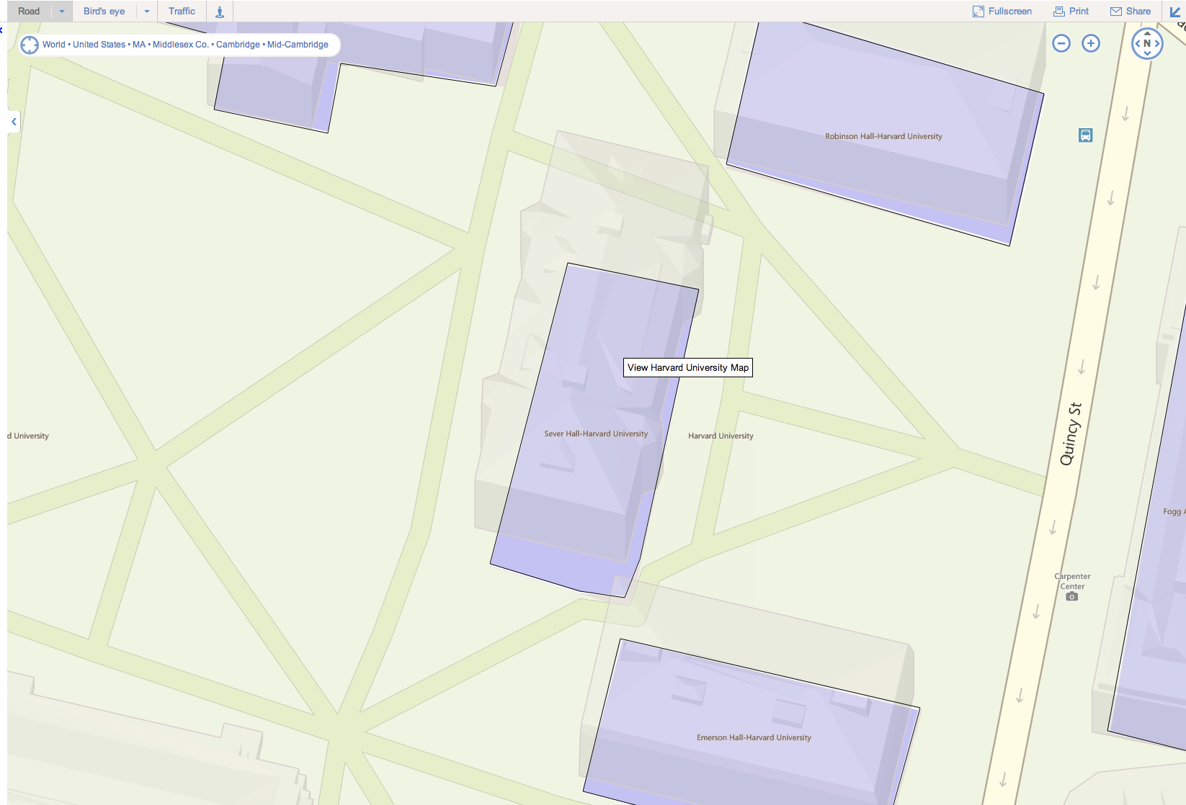

Satellite view:

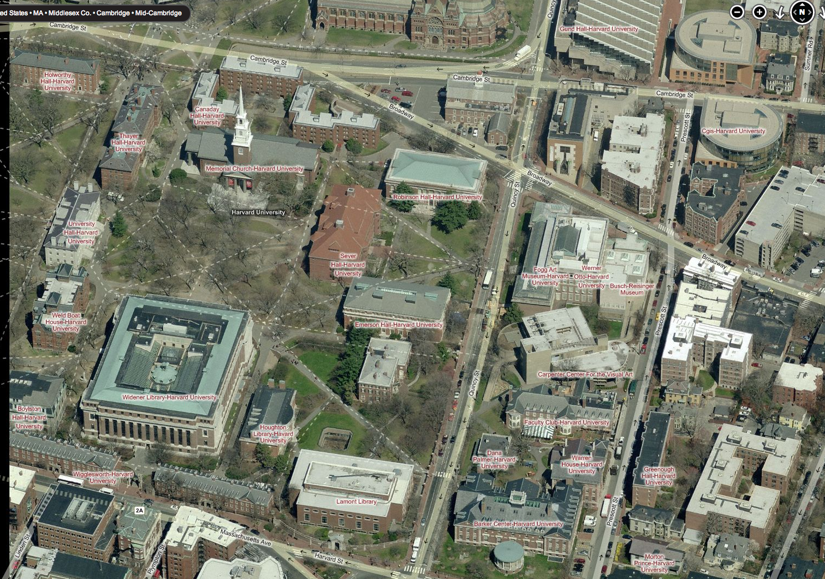

Path search:

